Wonder – Letter to the Author

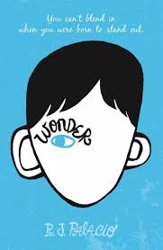
First, choose your own precept. If you’re having trouble finding one, do a Google search and type in “inspirational quotes for kids”.

Once you have your quote, interview 3 adults. Ask them what they think your precept means, and ask them to give a real life example. Write down what they say.

Now that you understand the “deeper meaning” of your precept, write a personal letter to the author of Wonder, R.J. Palacio.

- First paragraph – Introduction

- Second paragraph – Tell Mrs. Palacio what your precept is, who said it, and what you think it means. Give a real life example.

- Third paragraph – Tell Mrs. Palacio what you think the theme of her book was. Use several examples from the story. Show evidence from the story! Elaborate!

- Fourth paragraph - Tell her about your thoughts and feelings about the book. Tell her what your favorite part was.

- Fifth paragraph – Conclusion.

When we’re finished writing, we will attach this letter next to your “Wonder Face” artwork and display it somewhere in the classroom!

